 | Monday | Tuesday | Wednesday | Thursday | Friday
10:15 | Morning Check In  FaceBook Live | Morning Check In  FaceBook Live | Morning Check In  FaceBook Live | Morning Check In  FaceBook Live | Morning Check In  FaceBook Live
10:30 | Assertiveness & Self-Empowerment  David/Zoom | Art Where You Are  Jerry/Zoom | Mental Health Tips  Ernest/Facebook Live | PTSD & Recovery  Maria/Zoom | Creating a Healthy, Balanced Life  Clayton/Facebook Live
 |  |  | Sports Talk & Trivia  Chris/Youtube Live | Mental Health Tips & Tools  Ernest/Facebook Live
11:45 | Weight Loss & Management Support Group  Maria/Zoom | Connectedness  David/Facebook Live | Recovery Boosters  Clayton/Facebook Live | Ask the RC  Bill & Amanda  Facebook Live | Nutrition & Healthy Cooking  Maria/Facebook Live
 |  | Guided Meditation  Emily/Zoom | RCHC Jeopardy  Amanda/Zoom | 12:00 PM  A.S.L. Check-In  Vickie/Zoom | Staying Spiritually Grounded in Tough Times  Fred/Zoom
1:30 | Attitudes of Gratitude  Brian/Facebook Live | Creative Writing  Brian/Zoom | Technology Tips & Tools  Ernest/Zoom | Bipolar & Depression Support Group  David/Zoom | WHAM  David/Zoom
Healing Through Arts
Mary/Facebook Live
2:45 | Afternoon Check In/Q & A  Zoom | Afternoon Check In/Q & A  Zoom | Afternoon Check In/Q & A  Zoom | Afternoon Check In/Q & A  Zoom | Afternoon Check In/Q & A  Zoom
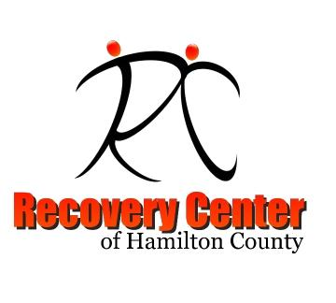
Recovery Center of Hamilton County
Online Class and Meeting Schedule
Effective May 4, 2020

