 | Monday | Tuesday | Wednesday | Thursday | Friday
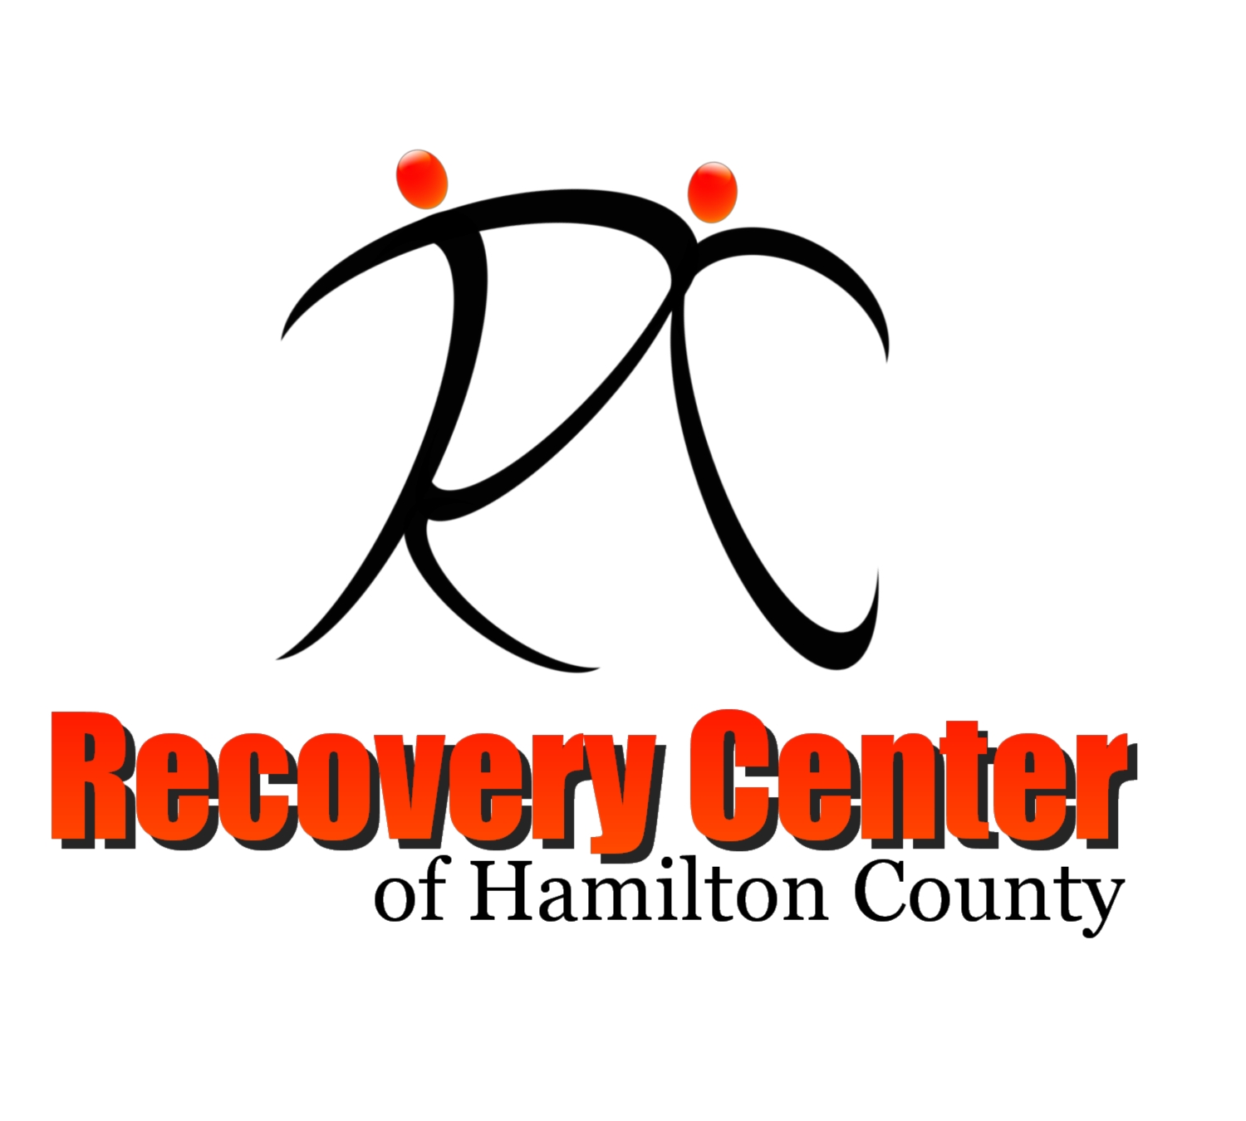  10:15 | Morning Check In  FaceBook Live | Morning Check In  FaceBook Live | Morning Check In  FaceBook Live | Morning Check In  FaceBook Live | Morning Check In  FaceBook Live
10:30 | Assertiveness & Self-Empowerment  David/Zoom | Mindfulness Journaling  Recovery Center of Hamilton County  Online Class and Meeting Schedule  Effective July 7th, 2020  Mary/ Youtube Live | Yoga With Cheryl  Facebook Live | PTSD & Recovery  Maria/Zoom | Creating a Healthy, Balanced Life  Clayton/Facebook Live
 |  |  | Social Issues Community Support Group  Ernest & David / Zoom | Mental Health Tips & Tools  Ernest/Facebook Live
11:45 | Weight Loss & Management Support Group  Maria/Zoom | Stay Connected to Yourself!  David/Facebook Live |  | Ask the RC  Bill & Amanda/Facebook Live | Nutrition & Healthy Cooking Class  Maria/Facebook Live
 |  | D.B.T Skills  Mary/YouTube Live | Boost Your Recovery!  Clayton/ Facebook Live | 12:00 PM  A.S.L. Check-In  Vickie/Zoom | Staying Spiritually Grounded in Tough Times  Fred/Zoom
1:30 | Attitudes of Gratitude  Brian/Facebook Live | Creative Writing  Brian/Zoom | Healing Through Arts  Mary/Facebook Live | Bipolar & Depression Support Group  David/Zoom | Easy Goal-Setting! (WHAM)  David/Zoom
RCHC Jeopardy
Amanda/Zoom
2:45 | Daily Peer Support Group  Zoom | Daily Peer Support Group  Zoom | Daily Peer Support Group  Zoom | Daily Peer Support Group  Zoom | Daily Peer Support Group  Zoom

