 | Tuesday | Wednesday | Thursday
10:30 | 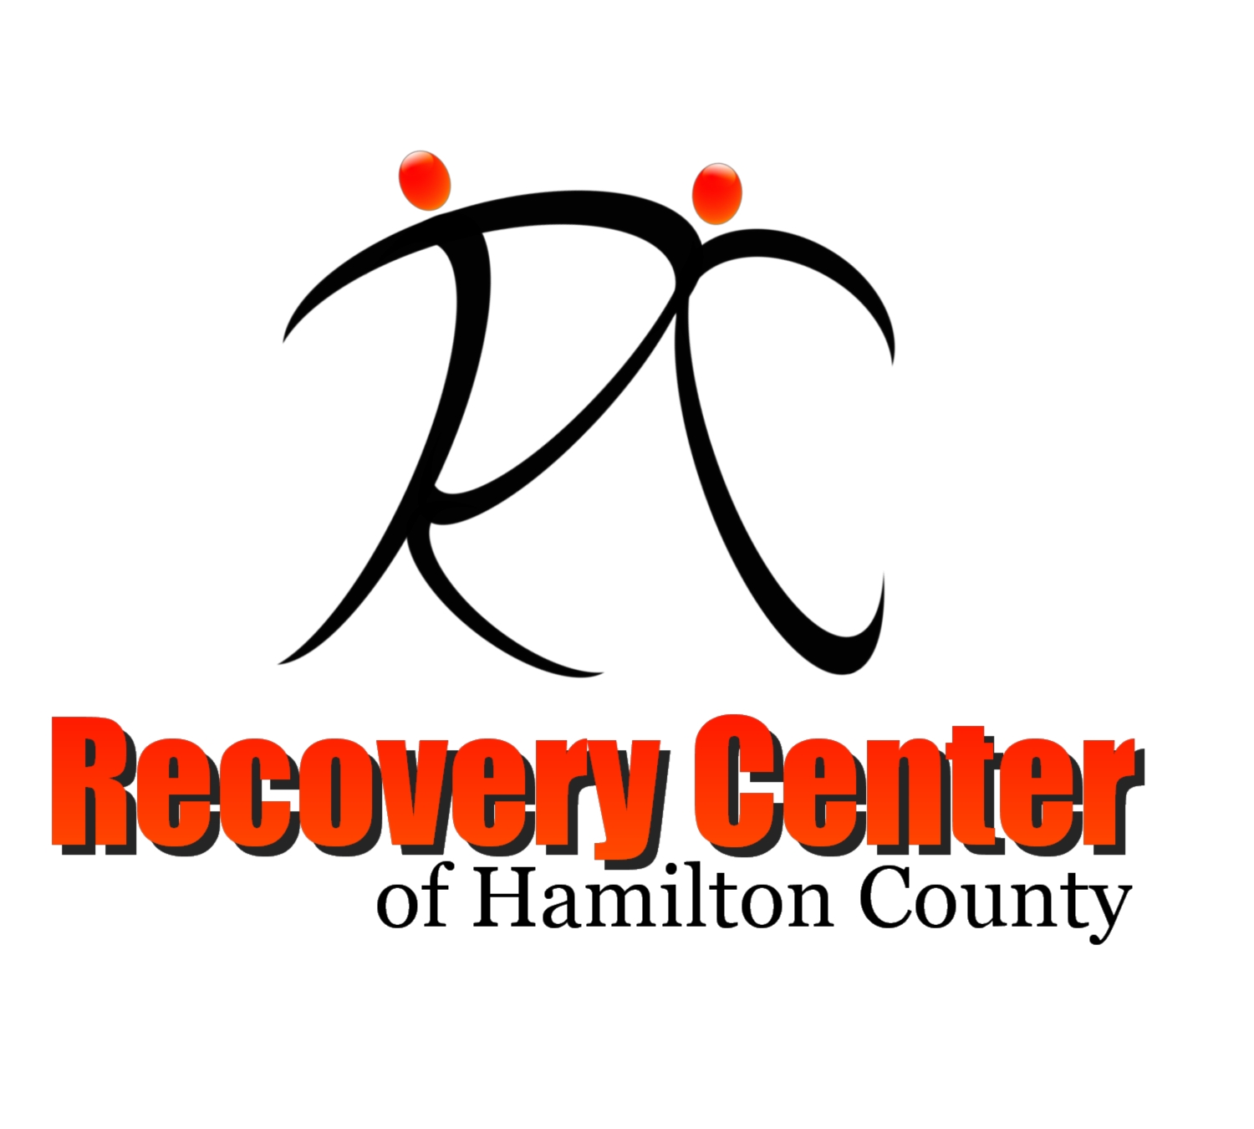  Art Where You Are With Jerry  Multipurpose Room | Yoga with Cheryl  Multipurpose Room | PTSD & Recovery With Maria  Multipurpose Room / Zoom
 | Mindful Journaling with Mary  Overflow Room | Healing Through Arts with Mary  Overflow Room | Signing for Recovery with Regina  Angela’s Room
Chair Boxing with Pam
Multipurpose Room
11:45 | D.B.T Skills with Mary  Angela’s Room / YouTube Live
 | Stay Connected to Yourself with David  Multipurpose Room / FB Live | Recovery Boosters with Clayton  Angela’s Room / FB Live
Technology Help With Ernest
Computer Lab

1:30 | True Defense with Master K  Multipurpose Room | Art at Essex With Jerry  Multipurpose Room | Bipolar & Depression Support Group with David and Mary  Multipurpose Room / Zoom
 | Creative Writing with Brian  Overflow Room / Zoom |  | Watercolor with Jerry  Overflow Room
2:45
Recovery Center of Hamilton County
In-Person Class and Meeting Schedule
Effective July 6, 2020

www.recoverycenterhc.org Promoting Wellness. Inspiring Hope. Changing Lives Facebook: @RecoveryCenterCincy

